02/25/2014

Version 3.2
Version 3.2
When we launched Series Seed we committed to making them a crowd-sourced set of documents. With today’s release of version 3.2 we are taking our most significant step in this direction. The vast majority of the changes in this version are crowd-sourced optimizations to remove legalese. In particular, we’d like to thank the following commenters and contributors for their effort: @rickcolosimo @zekevermillion @thesmart @strikeroot @sblom @jackmaney @blueseed @commonaccord.
Keep the comments coming! We are committed to continually improving and simplifying these documents.
Also, we’ve been asked to address changes in the laws with regard to general solicitation. We will make an update in the next version and are happy to see any suggestions in the interim.
As always, clean and redline versions of the updated documents are attached to this blog post and are also live on GitHub.
DOWNLOADS:
Series Seed Documents:
Series Seed - Term Sheet
Series Seed - Stock Investment Agreement
Series Seed - Certificate of Incorporation
Redlines:
Redline - Term Sheet 3-2 v 3-1
Redline - Stock Investment Agreement 3-2 v 3-1
Redline - Certificate of Incorporation 3-2 v 3-1
Posted at 04:21 PM in Financing Documents | Permalink | Comments (0) | TrackBack (0)
Reblog (0)

06/18/2013

Version 3.1
Today we are launching Version 3.1 of the Series Seed documents. The changes in this version are minor clarifications in response to comments we received via GitHub and other optimizations that we found as we went back through the documents. Clean and redline versions of the updated documents are attached to this blog post and are also live on GitHub. Thanks to the GitHub commenters. Keep the feedback coming!
Version 3.1 - Update Summary:
Term Sheet
- Changed the description for Documentation to be identical to (rather than based on) the documents on seriesseed.com, except for the modifications set forth in the Term Sheet. The whole point of the Series Seed documents is to save on transaction costs by using a single standard document so we don't want folks agreeing to use Series Seed and then adding changes (unless they are agreed to in the term sheet).
Stock Investment Agreement
- Removed unnecessary reference to preemptive rights in Section 4.2.
- Moved definition of “Stockholder” to earlier in document, from Section 7.1 to Section 5.3.
- Added clarifying sentence in Section 8.1 that “no Stockholder may transfer Shares unless each transferee agrees to be bound by the terms of this Agreement.”
- Added further clarification in Section 8.8 that “the addition of a party to this Agreement pursuant to a transfer of Shares in accordance with Section 8.1 shall not require any further consent.”
- Added new language to Disclosure Schedule clarifying arrangement of sections and providing standard disclaimers. The previous version did not have any introductory language for the Disclosure Schedule.
Series Seed Documents
Series Seed - Preferred Stock Investment Agreement
Series Seed - Restated Certificate of Incorporation
Series Seed - Term Sheet
Redlines
Redline - Stock Investment Agreement 3-1 vs 3-0
Redline - Term Sheet 3-1 vs 3-0
Posted at 10:54 AM in Financing Documents | Permalink | Comments (0) | TrackBack (0)
Reblog (0)

02/26/2013

For Law Nerds and Real Nerds

For Law Nerds
As we mentioned in our previous post, most of the edits to Version 3.0 of Series Seed are formatting related. This section of the blog will break down most of our edits, and for those of you not ready to take the plunge into GitHub, we have included Word documents and redlines against Version 2.0.
First and foremost, the largest formatting change is the merging of the previous Investors’ Rights Agreement and Stock Purchase Agreement into one new document called the Stock Investment Agreement, which covers all of the provisions of the previous two documents. Second, we have moved all of the variable definitions in the Stock Investment Agreement up to the front of the document, which allows for easier editing of the “fill in the blank” definitions that previously appeared throughout the documents. Third, we have updated references to written signatures and communication to allow for electronic methods like email. If you look at the redlines, you’ll see a lot of red ink, but these formatting changes account for 99% of it.
Substantively, the largest change is that we have added five standard carve outs based on the NVCA model documents to the drag along provisions in Section 5.4 of the Stock Investment Agreement. These are standard provisions that many parties were modifying the previous versions of the documents to include, so we added them.
We also removed the contribution to escrow provision that previously existed in Section 1.3.2 of the Restated Certificate of Incorporation. This was one of those provisions that caused some friction between Investors and the Company. My view is that if the provision is silent, then the liquidation preference must be fully satisfied prior to including any preferred funds in escrow, but remaining silent leaves this in doubt. For any brave souls taking another view (and giving an opinion on the same!), it also kicks the issue down the road until the Series A round when it makes sense to negotiate a nuanced issue like this.
The rest of the changes tend to be smaller updates, like changing the dollar threshold for disclosure of agreements from $25,000 to $50,000 or for disclosure of liabilities from $5,000 to $25,000 individually and $25,000 to $100,000 in aggregate. These and the other edits were in response to how we found that people were actually using the documents in practice. As always we’d love to get your feedback but you’re going to need to use GitHub!

For Real Nerds
Even though I was a double major in History and Latin, GitHub has become a part of my everyday conversation. It seems like these days engineers don’t have resumes, just GitHub accounts. You can read more about this amazing company here. This section attempts to give a brief overview of GitHub and how to contribute to a project like Series Seed even if you are a simple country lawyer.
To contribute, there are really only two core concepts that you need to know: 1) how to submit a request to change a document, called a pull request and 2) how to leave a more general comment, called opening an issue. We’re only going to cover the most basic functionality possible here, but we would encourage you to continue learning about how to use GitHub’s more advanced features here. Before doing any of this though, you’ll need to create an account on GitHub and be logged in.
Pull requests
A pull request is simply a requested change to a document. If there is a specific change to the text of a document that you have in mind, you should submit a pull request. If your comment is more general in nature, you should open an issue instead, which is described in the next section.
You can submit a pull request using GitHub’s new online editing functionality by first navigating to a project page and clicking on the particular document for which you want to submit your change. The project page for Series Seed is at https://github.com/seriesseed/equity.
You will see a list of documents so select the document you wish to edit, for example, if you click on the “Stock Investment Agreement” in the main body of the page you will be taken to the page for that particular document. On that page you will see buttons at the upper right hand corner of the document that looks like this:
If you click “Edit” GitHub will open a new editing pane, where you can select “Soft wrap” from the drop down menu in the upper right, it will make the edits easier to see. The dropdown menu looks like this:
Once you’ve clicked “Soft wrap” to change to the easier editing view, you can scroll through the document to make your changes. When you are done, try to describe what you’ve done in the boxes below your edits and hit the “Propose File Change” button at the bottom of the screen.
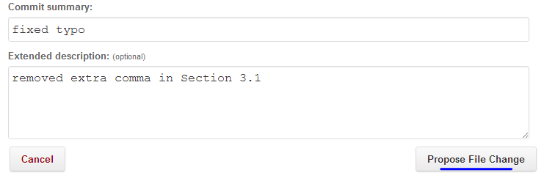
When you hit the “Propose File Change” button you’ll begin the process of submitting a pull request to the Series Seed team. You’ll be able to preview your request on this page:
You can insert a description of the change you are requesting plus any additional color. Once you click “Send pull request,” that’s it! You’ll have submitted your pull request for review. GitHub will automatically take you to the discussion page for the pull request that you opened, which will look like this:
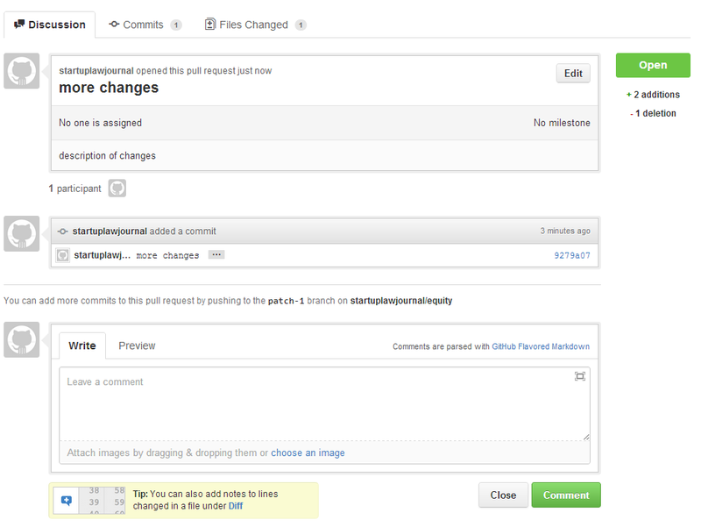
You don’t need to do anything on this page, unless you would like to add some more comments to your pull request. The Series Seed team will try to leave some feedback on all pull requests. Congrats on submitting your first pull request!
You can always come back to check the discussion and status of your pull request by navigating to the “Pull requests” tab at the top of the project page that looks like this:
There you will see a summary of all the open pull requests and, by clicking on an individual pull request, you can enter the discussion area to see if there have been any comments or discussion on your suggestion.
For more reading, GitHub has a great help page for submitting a pull request here. More general information on the topic of pull requests is here.
Issues
If you have a more general comment or discussion item that doesn’t translate to a specific edit, you should open an issue rather than a pull request. On the project page, right next to the pull requests link, is a link to the “Issues” page. If you click on that link you will be taken to the issues page for that project. It should look something like this:
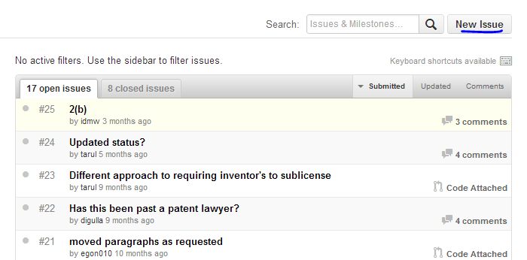
Before submitting an issue, you should use the search bar to look to see if anyone has already brought up your point. If not, just click the “New Issue” button and describe the issue you have in mind. The page will look like this:
Try to be as descriptive as possible. When you are done, click “Submit new issue” and you will be taken to the page for your submitted issue.
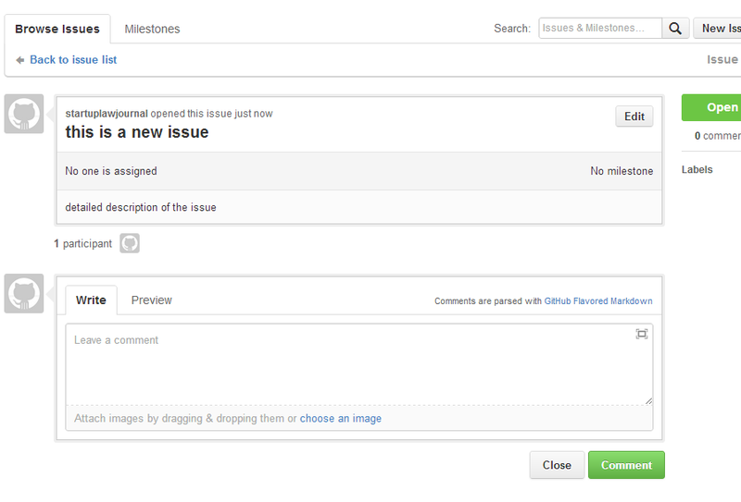
You don’t need to do anything on this page unless you want to leave another comment on the issue. You can come back at any time to check the status of your issue by clicking on the “Issues” tab at the top of the screen. If your issue gets resolved, it will be marked as closed and moved to the closed issues tab. You can also browse around these tabs and comment on issues that other people have opened.
For more help, please refer to the GitHub help pages.
Posted at 02:47 PM in Financing Documents | Permalink | Comments (0) | TrackBack (0)
Reblog (0)

01/31/2013

Version 3.0 and GitHub
The Series Seed documents were an attempt to take a more modern technology-based approach to seed financing. By creating a simple public standard, we hoped to help reduce the time and costs of these transactions. With Version 3.0 we have attempted to move even further in this direction by creating a set of documents that are easier to use and storing these documents in a place where they can develop and spread more efficiently.
The focus for Version 3.0 is on making the Series Seed documents easier to use both online and offline. A larger percentage of closings happen almost entirely online and we modified the documents to make them work more easily with various software platforms. As one example, we’ve collaborated with the folks at AngelList to ensure that this version of the documents works with their online closing process. Accordingly, the bulk of the updates in Version 3.0 are formatting related. For example, the previous Investors’ Rights Agreement and Stock Purchase Agreement have been combined into one new document called the Stock Investment Agreement. We have also moved all of the variable definitions to the front of the document so that all of the changes in the document are in one easy to find location instead of scattered throughout the document. For the law nerds out there, we summarize the full list of edits in Version 3.0 here.
Version 3.0 will also begin using GitHub as the platform for managing the discussion and update process for the Series Seed documents. Engineers in our community use GitHub to showcase their work, solicit feedback, and make their project better through teamwork. We are taking a page from their playbook. Legal documents operate a lot like software (although they rely on a human interpreter) so GitHub is a logical place for these documents to reside. GitHub will also move the discussion away from the blog comments and private email chains to a more community oriented forum. For you luddites out there a Word copy will be available on this blog.
Using GitHub will also allow us to explore options for the documents that are clunky with a pure Word document. For instance, we could have multiple branches of the documents, like a “no blocking rights” branch of the documents where the preferred stockholders would not have a blocking right on an acquisition as they do in the main Series Seed documents. This “branch” would still receive changes made to the main documents. Branching will allow separate and distinct versions of the Series Seed documents that can all benefit from the common portions. For example, a particular venture fund could have its own version of the documents where the differences would be easy for entrepreneurs to see and understand. For those that haven’t used GitHub before but would like to try contributing via GitHub, we walk you through the process here.
The initial goal of the Series Seed documents was to create a simple set of form financing documents that community members could use as a standard to save time and money. We’ve had great success with these efforts as many companies took advantage of this free resource. With Version 3.0 we have attempted to further simplify the documents and modify them to work with evolving platforms. We hope you find this update useful and look forward to your feedback. I want to thank Jason Boehmig of Fenwick & West for his efforts in moving these documents forward. This is just one of the projects he is working on to help modernize the startup practice
Series Seed Documents
Series Seed - Preferred Stock Investment Agreement
Series Seed - Restated Certificate of Incorporation
Series Seed - Term Sheet
Redlines
Redline - Stock Investment Agreement 3-0 vs Stock Purchase Agreement 2-0
Redline - Stock Investment Agreement 3-0 vs Investors Rights Agreement 2-0
Redline - Restated Certificate of Incorporation - 3-0 vs 2-0
Redline - Term Sheet - 3-0 vs 2-0

BEFORE DOWNLOADING THESE DOCUMENTS PLEASE READ THE DISCLAIMER
Disclaimer
Neither I nor Fenwick & West, LLP assumes any responsibility for any consequence of using these documents. These documents have been prepared for informational purposes and is not intended to (a) constitute legal advice (b) create an attorney-client relationship (c) be advertising or a solicitation of any type. Each situation is highly fact specific and requires a knowledge of both state and federal laws and therefore any party should seek legal advice from a licensed attorney in the relevant jurisdictions. Both I and Fenwick & West expressly disclaim any and all liability with respect to actions or omissions based on this website.
Posted at 01:37 PM in Financing Documents | Permalink | Comments (0) | TrackBack (0)
Reblog (0)

09/02/2010

Version 2.0 and why Series Seed Documents are better than capped convertible notes
“First they ignore you. Then they laugh at you. Then they fight you. Then you win.” Mahatma Gandhi
I hesitate to use a quote from one of the greatest people ever to grace planet earth, and certainly the question of how to structure early stage investment is a laughable cause as compared to the rights that Ghandi (also a lawyer) fought to advance. That said, I think this quote accurately captures the life-cycle of creating a simple set of documents for early stage investment.
I’ve attached version 2.0 of the Series Seed Documents as well as a red-line showing the changes I’ve made from the original set. If you peruse the red-line, you will see that there are not many changes. That’s because there are not that many issues to negotiate in a simple equity financing. Of course, one could argue, that I’m just not taking comments I disagree with (or that nobody cares enough to comment), but I am of the opinion that these documents represent the 95% consensus of what should be in a very basic set of equity financing documents. Based on the comments received, both on the blog and in the many deals in which these documents have been used, I am convinced that the terms of a simple set of equity documents are really not an issue. I don’t mean to say that the Series Seed are infallible, but there are no major objections to their content.
Why use Series Seed Documents instead of capped convertible debt? This seems to be the real issue. In my opinion, the reason that capped convertible debt is the current market leader is that entrepreneurs have been conditioned over time to believe that convertible debt is (a) faster (b) cheaper and (c) better for them than equity investment. This is EXACTLY why I created the Series Seed Documents. With Series Seed:
· Costs should be roughly the same (if not cheaper) than using industry standard debt documents. There are a number of different convertible debt documents out there and there will likely be some back and forth whereas these are standard documents.
· Same point for speed. If parties agree to Series Seed Documents, should be faster than debt documents since there is some negotiation with debt documents from sophisticated investors.
· Series Seed Documents are transparent: no hidden gotchas can get served up in definitive documents. You can review them right now if you want.
· Equity documents give investors more clear definition around rights, more stability and less potential squabbling in the next round.
· Equity gives investors the opportunity to get long term capital gains tax treatment if early exit.
· With minor manipulation, Series Seed enables multiple board structures without tortured and non-functioning agreements (a real problem for convertible debt documents); and
· Entrepreneurs get price certainty instead of the lower of two different prices as with capped debt.
In sum, Series Seed creates a level playing field between capped debt and equity documents in terms of speed and cost. When one studies the (admittedly highly technical) benefits of Series Seed vs. price debt, Series Seed is a better solution.
There has been a robust debate on this topic with folks like Fred Wilson, Paul Graham and Seth Levine all chiming in. To clarify, there is no question that as an entrepreneur you would prefer uncapped convertible debt to equity. As Josh and many others point out, this is typically not a fair deal for the investors and many investors won’t do it, or will only do it for people that they are blindly in love with. Also, Seth raises some interesting points about ecosystem health, though most entrepreneurs I know aren’t too concerned about killing the golden goose. Once a price cap has been introduced, however, Series Seed Documents are a better solution to getting the first round complete for both entrepreneurs and investors.
Redlines
Redline - Series Seed COI (1 v. 2)
Redline - Series Seed IRA (1 v. 2)
Redline - Series Seed Term Sheet (1 v. 2)
Series Seed Documents
Series Seed COI (v 2.0)
Series Seed IRA (v 2.0)
Series Seed Term Sheet (v 2.0)
Series Seed Form SPA
BEFORE DOWNLOADING THESE DOCUMENTS PLEASE READ THE DISCLAIMER
﻿
Disclaimer
Neither I nor Fenwick & West, LLP assumes any responsibility for any consequence of using these documents. These documents have been prepared for informational purposes and is not intended to (a) constitute legal advice (b) create an attorney-client relationship (c) be advertising or a solicitation of any type. Each situation is highly fact specific and requires a knowledge of both state and federal laws and therefore any party should seek legal advice from a licensed attorney in the relevant jurisdictions. Both I and Fenwick & West expressly disclaim any and all liability with respect to actions or omissions based on this website.
Posted at 12:24 PM | Permalink | Comments (11) | TrackBack (0)
Reblog (0)

05/24/2010

Step 2 (as opposed to version 1.1)
Redline - Series Seed v. Series Seed to Series A COI
Redline - Series Seed v. Series Seed to Series A SPA
Redline - Series Seed v. Series Seed to Series A IRA

BEFORE DOWNLOADING THESE DOCUMENTS PLEASE READ THE DISCLAIMER
Disclaimer
Neither I nor Fenwick & West, LLP assumes any responsibility for any consequence of using these documents. These documents have been prepared for informational purposes and is not intended to (a) constitute legal advice (b) create an attorney-client relationship (c) be advertising or a solicitation of any type. Each situation is highly fact specific and requires a knowledge of both state and federal laws and therefore any party should seek legal advice from a licensed attorney in the relevant jurisdictions. Both I and Fenwick & West expressly disclaim any and all liability with respect to actions or omissions based on this website.

One of the most difficult decisions in creating the Series Seed Documents was whether to make them a very simple version of traditional Series A documents or a more radical departure from the traditional format (to the extent that corporate finance legal documents can be referred to as radical).
I opted for the latter approach for a number of reasons. First, I thought it would be best to make these documents as simple as possible. Second, I wanted the documents to human readable (as opposed to lawyer readable) and there are certain provisions of a vanilla set of Series A financing documents that are just too dense for most civilians to get through (e.g. price based anti-dilution). Third, although the more simple documents require more tweaking in the next round of financing, that next round of financing should be a bigger round with resources where such investment would be appropriate. Let’s imagine that using the more simple documents saves 10% of the time and money involved in a seed financing. Even if it takes 20% more time to add a full set of provisions in the next round, that’s a good deal because (a) fewer than 50% of seed financed companies make it to the next round and (b) the dollars in the next round are less dear at that time, since it is a larger fundraising.
Accordingly, in this post I’ve attached a sample of the Series Seed Documents with a traditional set of financing provisions added.
What these documents are:
So the purpose of these documents is to give a legal practitioner an example as to how to drop traditional financing terms into the Series Seed Documents. I based these documents off a recent transaction where a company that had used the Series Seed Documents raised a Series A round. As expected, that deal took a bit longer than it would have had the Company raised a vanilla Series A to begin with (and subsequently raised a Series B) but the aggregate fees for the two transactions were still less than the standard Series A followed by a Series B. Moreover, with a good roadmap to follow, these costs elements will decrease over time.
What these documents are NOT:
It is important to note that these documents are just intended to be instructive as to how to go from a Series Seed to a Series A. I am not intending to standardize Series A terms. For this reason, I’ve not included a Right of First Refusal and Co-Sale Agreement or a Voting Agreement, both of which are typical in a Series A financing. It should be noted that the Drag Along and ROFR provisions in the Series Seed Documents should wind up in the Voting and Right of First Refusal Agreement, respectively so they appear to be deleted from these documents. Also, I’ve gotten a lot of request to post other form documents online. Keeping a full library of up to date form documents that comply with various state requirements is way out of scope. The Series Seed project is about standardization of a simple equity financing transaction. I do not intend to go beyond that.
Additionally, these documents are not version 2.0 of the Series Seed Documents. I will have that out by the end of summer. I’ve received numerous helpful comments both on the blog and via email and if you have any more to share, please do so.
How’s it going otherwise?
I've gotten very good feedback from my partners and other practitioners about the Series Seed Documents. I’ve used these documents a number of times in my own practice and I can tell from the statistics at www.SeriesSeed.com that many folks have downloaded them. If you have any success stories to share, let me know. I'd love to hear about it.
My expectation around these documents is that they will take about 5 years to gain mainstream adoption. Even with my great launch partners using them, it takes time for a new standard to emerge. I'm hopeful that tools like this Series Seed to Series A roadmap, will help make that happen. If you have any suggestions, let me know.
Posted at 11:02 AM | Permalink | Comments (1) | TrackBack (0)
Reblog (0)

02/25/2010

Series Seed Financing Documents
Please note, these are the latest versions of the Series Seed Documents.
Series Seed COI (v 2.0)
Series Seed IRA (v 2.0)
Series Seed Term Sheet (v 2.0)

These are the original versions of the Series Seed Documents.
Series Seed COI
Series Seed IRA
Series Seed Term Sheet
Series Seed Form SPA

BEFORE DOWNLOADING THESE DOCUMENTS PLEASE READ THE DISCLAIMER
﻿

Disclaimer
Neither I nor Fenwick & West, LLP assumes any responsibility for any consequence of using these documents. These documents have been prepared for informational purposes and is not intended to (a) constitute legal advice (b) create an attorney-client relationship (c) be advertising or a solicitation of any type. Each situation is highly fact specific and requires a knowledge of both state and federal laws and therefore any party should seek legal advice from a licensed attorney in the relevant jurisdictions. Both I and Fenwick & West expressly disclaim any and all liability with respect to actions or omissions based on this website.
Posted at 02:01 PM | Permalink | Comments (33) | TrackBack (0)
Reblog (1)

02/24/2010

About the Series Seed Documents
A decade ago, a company would need to raise a couple of million of dollars to create a new product and effectively bring it to market. Today that amount is dramatically smaller. The advent of cloud computing, open source software, platforms with APIs, and numerous other changes have lowered the cost of launching a new enterprise. For this reason, startup companies are now raising significantly less capital – and many investors have begun to focus efforts on this smaller early stage investment – which typically ranges from $500,000 to $1.5 million.
Yet amidst all these other dramatic changes, one aspect of startup life has not changed at all: the legal documents used for financing these transactions. A typical venture capital investment package consists of five documents: two certificates, a legal opinion and two consents, and is roughly 100 pages long (excluding signature pages). These documents provide for a range of rights, preferences and privileges, some of which are vitally important to protect the investment from the outset and others of which do not become important until after the company has gone public. This level of investment in financing documentation made sense when the investments were $3 million to $5 million, but for these smaller seed stage rounds, it’s simply overkill.
The Series Seed Documents have been created to address these issues. They are considerably shorter and simpler than the status quo investment documents, designed to keep the most essential terms for the transaction and postpone the other terms for a later fundraising round where such an investment would be warranted. A more detailed description of the content of these documents and rationale behind them can be found here.

The Series Seed Documents should reduce both the time and cost of a financing transaction. It should go without saying, but time and money are the two things most vital to a young company.
From an investor’s perspective, while moving away from the traditional full-blown financing documents entails giving up a number of rights and protections, when taken across numerous transactions, the benefits of spending less time and money on the documents outweigh the cost of sacrificing these additional rights and protections. Moreover, I don’t believe there’s anything included (or excluded) in these documents that will be wildly controversial. Based on discussions with numerous practitioners, I believe these documents largely represent a consensus as to what should be in seed round documents. Additionally, I plan to “open source” the documents so that they can be continually improved by suggestions from the community.

A few principles have animated this approach:

• First, these documents are intended to be fair, favoring neither the investors nor the entrepreneurs. Any comments to the contrary or other suggested improvements can be made at the Series Seed blog; and I’m committed to periodically revising the documents to reflect such comments.

• Second, they are simple. Under the status quo, only the hardiest of entrepreneurs could reasonably be expected to slog through 100 pages of financing documents. The Series Seed Documents are only 30 pages in the aggregate so that an entrepreneur can read and understand them without devoting an inordinate amount of time and energy.

• Third, these documents are “fill in the blank,” meaning that they are intended to be used as-is without any further negotiation other than completing the requisite information necessary to make the documents accurate. Although there are costs in adopting a uniform approach in any single case, when taken over a large number of transactions, the aggregate value of standardization outweighs this cost.

• Finally, using the Series Seed Documents will increase transparency. Since these documents are available online, any entrepreneur or investor can now sign a term sheet with confidence that there are no hidden “gotchas” in the next stage of the process.

Some points of clarification about this project. First, these are not Fenwick & West or my own form documents. Although I undertook the laboring oar (with the assistance of Khang Tran) and many of my colleagues at Fenwick & West have assisted me in the original drafts, these documents are intended to be an open source project and not particular to any lawyer or law firm. Similarly, this is not an Andreessen Horowitz undertaking. Although I am pleased to have the firm’s support in launching this effort, the Series Seed Documents will require broad adoption in order to become an effective standard. The following investors have agreed to use the Series Seed Documents in certain of the their deals: Baseline, Charles River Ventures, SV Angel (Ron Conway), First Round Capital, Harrison Metal Capital, Mike Maples, Polaris Venture Partners, SoftTech VC and True Ventures. None of these investors intend that the Series Seed Documents be the only way to document a transaction, as there are a variety of scenarios where a more fulsome set of documents or another alternative structure would be preferable to either the investors or the entrepreneurs. Finally, please see the disclaimer. While I’m happy to make these documents available, they are yours to use at your own risk.

In conclusion, I feel very fortunate to be a part of the startup company ecosystem. Drafting these documents is a small way that I have sought to give something back to the community. I hope people find them useful and I look forward to working to improve them.
Posted at 05:53 PM | Permalink | Comments (11) | TrackBack (0)
Reblog (0)

For the Faithful
Overview
The Series Seed Documents are a standardized set of documents that can be quickly and easily deployed for a seed investment: to help get a company financed properly, legally quickly and intelligently.

Up until now, various smart people have talked or blogged about reducing the transaction costs associated with seed stage investment without rallying around a particular attack. Of course both entrepreneurs and investors would rather see their investment dollars used toward developing a new product and bringing it to market than toward what are usually routine transaction costs. The problem has been crafting a set of documents that provide adequate protections without being unduly burdensome. [more...]

Posted at 05:47 PM | Permalink | Comments (3) | TrackBack (0)

